 prints the square of each number from 1 to a give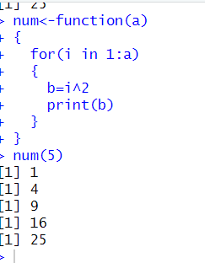

prints each element of the array.

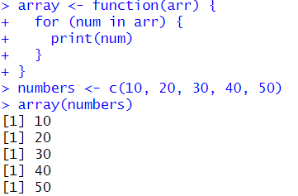

accessing specific elements of a vector and filtering elements in R

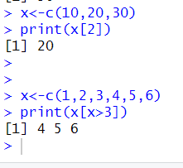

print the matrix before and after naming the rows and columns.

